Sitewide - Digital Asset Manager

July 2005
© 2000 - 2005 Fluke Corporation, All rights reserved. Printed in USA
All product names are trademarks of their respective companies.

Introduction 3
What are digital assets? 3
Interaction with Oracle Deliverables 4
Oracle Deliverables Meta Data 5
Single Digital Asset vs. a Collection of Digital Assets 7
SiteWide Digital Asset Fulfillment 9
Oracle Digital Asset Fulfillment 9
Conclusion 9

Introduction

“SiteWide” is the suite of web applications initially introduced in 2001, now in its fourth major revision. This suite of tools support the Partner Portal Sites on Support.Fluke.com and were designed to be a secure, self-publishing repository for all Marcom / Marketing digital assets such as PDF documents, Images, MSOffice files, software updates, plus all other electronic digital assets (files), with relational integration into enterprise systems such as Oracle.

Its ease in rapid deployment of new assets and the ability to provide these same assets to resellers, end-users, systems such as Print-On-Demand, Electronic Email Fulfillment (Oracle), Fluke Digital Library (on user facing websites such as www.fluke.com), etc., makes the Partner Portal application and its rich set of rendering and administration tools plus a host of other add-on utilities the primary mechanism for distribution of the same.

The main concept behind the Partner Portal is the ease of adding a digital asset. Besides the file itself, only the minimal other data is required, such as the Library category it should be shown in, the Product or Product Series it is related to, the Title of the asset and Description, Thumbnail image and the electronic asset itself.

Restrictions can be imposed to limit the view of this asset based on System, Group, Country, Begin Date, Public Embargo Date and automatic archival with it’s interface to Oracle Deliverables Fulfillment System.

In typical application, an automatic digital product launch on the Begin Date could be sent via the subscription email services world-wide, contain descriptions, thumbnails and encoded links to all of the digital launch materials.

Finally, the Partner Portals are multilingual, both in user view and administration tools.

This Content Administrator’s Users Guide will help you understand the asset creation process.

What are digital assets?

A digital asset can be anything that can be contained in a computer file. These include, MSOffice or other files, PDF files, Images, Software, Software Updates, Posters, Audio or Video Files, etc. In addition, digital assets can be website URL’s to other websites or specific pages on those websites, or gateways that pass authenticated user credentials to another application, etc. The end-point for a digital asset is almost endless. In other words if you can view it on your computer, chances are you can make that same media available via the internet to other users.

Interaction with Oracle Deliverables

Many digital assets in use by Fluke and its related brands are created by “Marcom / Creative Services” and flow through the standard OMD process with an end result of some an Oracle Item Number, internal control data and limited meta data that could be used outside of the OMD process.

SiteWide interfaces to this information via an Oracle to SQL DTS package that runs twice daily at 11:05am and 5:05pm PST. This task enables the SiteWide database sitting in the DMZ to have updated Oracle Deliverable status and revision information initially for pre-population of Partner Portal asset fields and controls the LIVE / Retired status of the asset (Oracle Item Numbers only.)

However, about 50% of all the assets “Marcom Collateral”, such as Ad reprints, Power Point presentations, Letters, etc., are not in Oracle Deliverables. This is in addition to non-Marcom Collateral such as software updates, manuals, support tools, etc.

Therefore if a change is considered to move some of SiteWide’s functionality upstream to Oracle, provisions need to be considered to provide this same functionality downstream for digital assets that do not fit “standard processes”, plus the business rules of who has access to what globally at the sales-channel level and end-user level.

Oracle Deliverables Meta Data

Currently, through the DTS package described above, Oracle provides to SiteWide certain status and Meta information as follows:

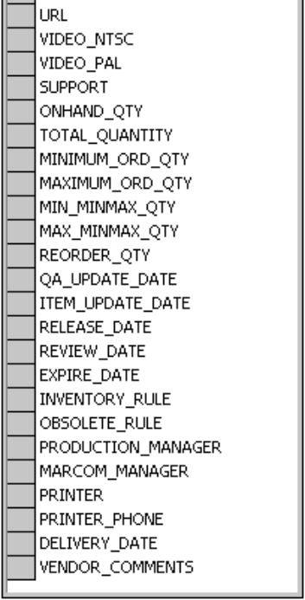
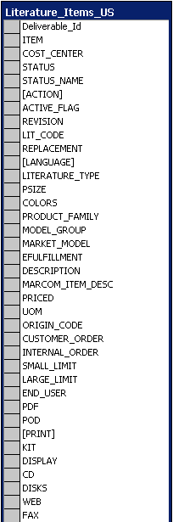

All of this information, with the exception of Item (Oracle Item Number), Cost Center, Status, Status Name, Action, Revision, Lit_Code, Language, PSize, Colors, EFulfillment, Minimum / Maximum Order Quantity (shopping cart), Marcom Manager, are essentially useless to external fulfillment applications. Most fields, with the exceptions noted above, contain non-standard nomenclature related to other systems, or legacy data.

Defining the Oracle Deliverable Meta Information in this system might be problematic, considering additions would have to be made to relate multi-lingual assets of the same, where to use (systems), who can use (channels / countries) and how to use (collections), when to use (embargo dates based on regions) and what to use (Low-Resolution, POD-Resolution, Thumbnail, Zip File of same that need to be based on the fulfillment and business rule definitions that change with each local.

When creating an asset in SiteWide for use on the Partner Portal (extranet) or for use via user-facing web sites, such as www.fluke.com/usen, SiteWide checks Oracle for meta data and prepopulates the asset definition form with the same. However, in many cases, with the exception of the current “Active” revision letter, Literature Type and Language, most of this data is “freeform text” and is not usable. Take for example, basic Title and Description Information.

Oracle currently provides this information (sample):

Item | Type | Family | Market Group | Market Model | Description
2434064 | Application Note | IAD | No Value | No Value | Take an existing Education app note and delete the education logo for use on the web and by other product groups. It is app note #2118045 A-ENG-Rev A. This is not a replacement, it is an exact duplicate of the existing app note just without the education logo. This one will be posted on the web and made available to non-education clients.
1996245 | Data Sheet | MEDIA | COPPE | DSPLIA | OMNISCANNER 2-Spanish
2132021 | Data Sheet | HHNT | No Value | No Value | ETHERSCOPE DATA SHEET
2461185 | Data Sheet | EPROD | No Value | No Value | China 1508 Data Sheet
2430859 | Ad | EPROD | No Value | No Value | 1508 China Ad
2458672 | Poster | EPROD | No Value | No Value | China 1508 Billboards
2458726 | P-O-P Displays | EPROD | No Value | No Value | China 1508 Lightbox
2444509 | Line Art | IAD | IA98 | No Value | 971 line art
2491448 | Ad | DMMS | No Value | No Value | 1/6 page b/w ad promoting the 1587
2464430 | E-Mail | CALIB | No Value | No Value | HTML email inviting people to the Fluke Met/SW user group meeting at NCSLI '05 in Washington DC.

SiteWide uses this information to pre-populate many of the asset’s fields, however as you can see the value of this data, especially Description is quite questionable.

In concept, to Oracle Deliverables you could add other fields such as Web Document Title, Web Description, Web Meta Keywords, etc., but it is my opinion that only fields that could be standardized and apply to all web systems should be added. Even with those additions, how do you handle the multi-lingual translation issues of the same titles, descriptions, etc., or any of the other regional differences for fulfillment as identified in the previous and post discussion of this document.

Marcom managers when considering the “Presentation of Assets” created in OMD and stored on a golden file system, take a different tack for each system that the asset may be used on. Since SiteWide’s initial goal was to provide rapid loading and configuration of assets for presentation to channels, it could easily be expanded to provide the P-Cat configuration as part of the asset’s presentation data as a [Configure P-Cat] link to a common program used by all Fluke brands including Fluke Networks.

P-Cat could use the Oracle high-level meta data directly from the Oracle to SQL DTS package in the SiteWide DB, or use access all of this presentation data via a call to SiteWide’s asset data table.

Single Digital Asset vs. a Collection of Digital Assets

SiteWide establishes and maintains a relationship between related digital assets. A collection is used to group these digital assets into a collection that can be fulfilled via on-line portal viewed, downloaded, emailed to self, emailed to an associate, sent out as a push-email (Subscription Service) or if an asset has a physical format, ordered via DCG.

Collections are extremely important for Campaigns (short term), Product Launches or grouping of related assets for Product Lines (life of the product.) An example of a collection might include a Introduction Letter (non-Oracle), Literature Items (Oracle), Ad Reprints (non-Oracle), a collection of images (ImageStore collection), Order Forms (non-Oracle), PowerPoint Presentations (non-Oracle), Tradeshow / Seminar event items (non-Oracle), links to other web pages (non-Oracle), etc. In the discussion consuming this paragraph, you also need to take into consideration rapid deployment of non-Oracle assets as a bridge for newly acquired companies, or outlying sites not served by the European, SiteWide, or CMS Site systems.

In addition collections can contain can be multi-lingual (related back to the English version), certain assets can be restricted to or excluded from a country or countries, assets can be restricted to or excluded from sales-channels; assets can have staggered go-live dates (sales channel and public.) Any combination of these controls can be applied to the entire collection (such as a Product Introduction), or to the individual assets that comprise the collection. (See example diagram on the next page.)
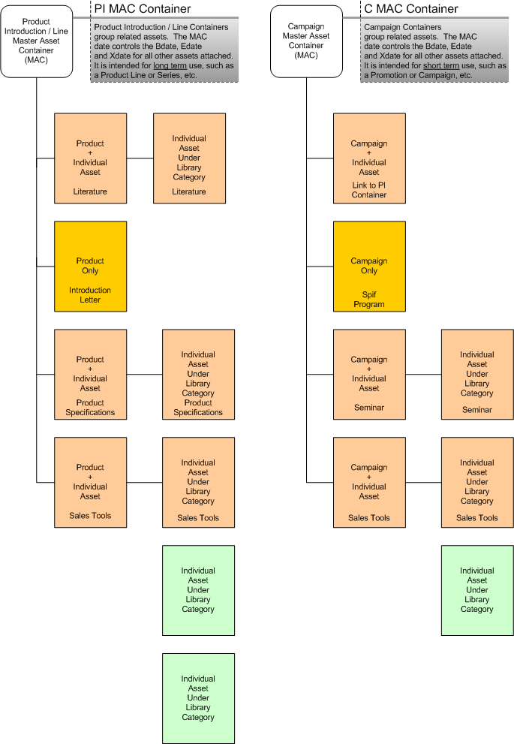

SiteWide Digital Asset Fulfillment

The mechanism that is used for fulfillment is a SiteWide application called “Find_IT”.

Prior to any fulfillment, Find_IT checks the Oracle status, and/or SiteWide status of the deliverable against the credentials of the user or system requesting the digital asset. It also, immediately reports back to the author of the digital asset (in Oracle or not), if the asset cannot be fulfilled, the reason for non-fulfillment and steps to correct it.

Every fulfillment interaction is recorded noting the method of fulfillment (view on-line, download, send by email to self, send by email to associate, order quantity by shopping cart (DCG), fulfillment by other websites, such as www.fluke.com/usen, www.fluke.com/caen, www.metermantesttools.com, etc., that use the Find_IT URL call to access the digital asset.

An enhancement to Find_IT is days away from completion that will allow streaming of the digital file, via changing the mime-type of the header and streaming the file data. The advantage of this method is that it hides the physical URL of the file, thus providing secure delivery without exposing the file’s URL or imposing server file/directory access authentication.

Oracle Digital Asset Fulfillment

From SiteWide’s perspective, the location of the Oracle Deliverable golden assets (in it’s various formats, PDF, POD, Thumbnail, MSOffice files such DOC, XLS, PPT and ZIP (zip archive for fulfillment through business firewalls blocking native files, such as EXE, etc.), high level meta data, revisioning and uploading of the same across the DMZ, is a solid enterprise solution and one that I would highly recommend.

Oracle is a Business System not a Presentation System.

When a new asset is added to the Partner Portal, using the Oracle Item number, could then pre-populate the asset’s header level meta data, such as Title, Description, Keywords, etc., but could automatically build a fulfillment URL or direct stream method to the golden deliverable. To provide the streaming method, the server would need file system access to the native file for binary read / write. Other systems such as www.fluke.com/usen could still use Find_IT or a native version of the same functionality on that site.

Conclusion

It would be prudent to enhance the Oracle Deliverable application and processes to “finish the job”, by providing revisioning and loading of the finished item to a golden repository for use by other web servers or information distribution systems. In addition, common Title, Description, Meta Keywords or other high-level data, such as status, should be initiated and maintained in Oracle. Presentation systems, such as SiteWide (Partner Portal), CMS and other information systems tasked with the channel / sales relationship, should be independent from Oracle to provide the presentation layer, but could greatly benefit from the high-level data collected up-stream during the OMD processes.

Compiled by: Kelly Whitlock

